H.T No
Regulations:
A15


Sreenidhi Institute of Science and Technology
(An Autonomous Institution)
Code No: 5B515 Date: 31-Dec-2019 (FN)
B.Tech III-Year I-Semester External Examination, Dec-2019/Jan-2020 (Supplementary)
Kinematics of Machinery (ME)
Time: 3 Hours Max.Marks:75

Note: a) No additional answer sheets will be provided.
b) All sub-parts of a question must be answered at one place only, otherwise it will not be valued.
c) Missing data can be assumed suitably.

Part - A Max.Marks:25

Answer all QUESTIONS.

1. | Distinguish between open and close kinematic pairs with examples. | [3M]
2. | Define class-I Four bar chain and mention any two inversions. | [3M]
3. | Sketch the Tchebicheff mechanism and mention it’s purpose. | [3M]
4. | Show the displacement, velocity and acceleration of the follower which moves with parabolic motion for one complete rotation of DRDR cam. | [3M]
5. | The arm OA of an epicyllic gear train shown in Fig.1 revolves counter clockwise about O with an angular velocity of 4 radians/second. Both gears are of same size. The angular velocity of gear C, if the sun gear B is fixed, is  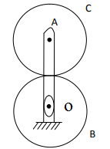  Fig.1 | [3M]
6. | Define centrifugal tension in belt drive and mention for what condition, it is to be considered. | [2M]
7. | Sketch and show all Instantaneous centers for a slider crank mechanism? | [2M]
8. | What is the condition for the correct steering? | [2M]
9. | What is backlash in gears? | [2M]
10. | How do you find the length of a chain? | [2M]
Part – B Max.Marks:50

ANSWER ANY FIVE QUESTIONS. EACH QUESTION CARRIES 10 MARKS.

11. |  | List the kinematic chains with four links and four lower pairs. Explain inversions of class-I and class-II four bar chains. | [10M]
12. |  | The device in Fig.2 is a sloshing bath used to wash vegetable produce. For the configuration shown, graphically determine the angular velocity and angular acceleration of the water bath as the crank is driven counterclockwise at uniform speed 100 rpm.  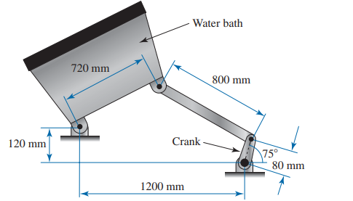  Fig.2 | [10M]
13. | a) | Sketch and explain the working principle of Ackerman steering gear mechanism. | [5M]
 | b) | Explain the Grasshopper mechanism. | [5M]
14. |  | A cam is used for a newspaper-collating device. The cam follower must rise outward 16 mm with uniform velocity motion in 120° of cam rotation, dwell for 30°, fall to the initial position with uniform velocity motion in 120° of cam rotation, dwell for 30⁰ . Graphically plot a follower displacement diagram and cam profile with inline flat faced follower and minimum diameter of cam 70 mm. | [10M]
15. | a) | Define interference in gears and mention the methods to eliminate interference. | [3M]
 | b) | A planetary gear train is illustrated in Fig. 3. The carrier (link 2) serves as the input to the train. The sun (gear 1) is the fixed gear and has 30 teeth. The planet gear (gear 3) has 35 teeth. The ring gear serves as the output from the train and has 100 teeth. Determine the rotational velocity of all members of this gear train when the input shaft rotates at 1200 rpm clockwise.  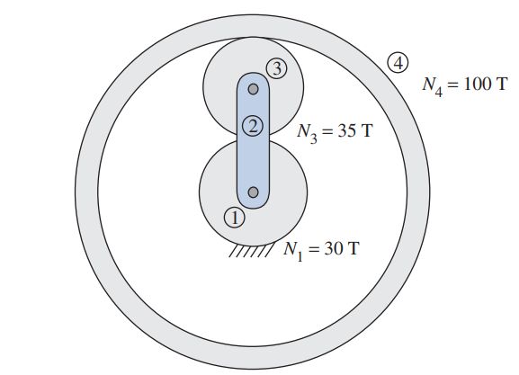  Fig. 3 | [7M]
16. | a) | Discuss relative merits and demerits of belt, rope and chain drive for transmission of power. | [3M]
 | b) | A rope drive is required to transmit 230 kW from a pulley of 1 meter diameter running at 450 RPM. The safe pull in each rope is 800 N and the mass of the rope is 0.4 kg per meter length. The angle of lap and the groove angle is 160° and 45° respectively. If the coefficient of friction between the rope and the pulley is 0.3, find the number of ropes required. | [7M]
17. |  | Explain Peaucellier exact straight line mechanism with a neat sketch. | [10M]
18. |  | Develop the expression for velocity of sliding between teeth. Also state and prove the law of gearing. | [10M]
-- 00 -- 00 –

